Koneru Lakshmaiah Education Foundation
(Deemed to be University)

Course Code: 22SDEC14R
Course Name: Embedded Prototype
(Skill Development Project-3)
A Project Report
On
Autonomous Drone System for Emergency Medical TransportationSUBMITTED BY:
2300040008- G.VASUDEVA
2300040027- S.MAHENTH SAI
2300040062- C.R.S. AKSHAY SRI DUTT
2300040069- K.SHANMUKHA JYOTHI PRIYA

UNDER THE GUIDANCE OF
Dr A V Prabhu
Associate Professor-ECE

Green fields, Vaddeswaram – 522 502
Guntur Dist., AP, India.

K L E F

DEPARTMENT OF ELECTRONICS AND COMMUNICATION ENGINEERING
(DST-FIST Sponsored Department)



DECLARATION

The Project Report entitled “Autonomous Drone System for Emergency Medical Transportation” is a record of bonafide work of 2300040008- G.VASUDEVA, 2300040027- S.MAHENTH SAI , 2300040062- C.R.S. AKSHAY SRI DUTT, 2300040069- K.SHANMUKHA JYOTHI PRIYA,submitted in partial fulfillment for the award of B.Tech in Electronics and Communication Engineering to the K L University. The results embodied in this report have not been copied from any other departments/University/Institute.

K L E F

DEPARTMENT OF ELECTRONICS AND COMMUNICATION ENGINEERING
(DST-FIST Sponsored Department)


CERTIFICATE
This is to certify that the Project Report entitled “Autonomous Drone System for Emergency Medical Transportation” is being submitted by 2300040008- G.VASUDEVA, 2300040027- S.MAHENTH SAI , 2300040062- C.R.S. AKSHAY SRI DUTT, 2300040069- K.SHANMUKHA JYOTHI PRIYA in partial fulfilment for the award of B.Tech in Electronics and Communication Engineering to the K L University is a record of bonafide work carried out under our guidance and supervision.
The results embodied in this report have not been copied from any other departments/ University/Institute.
Signature of Supervisor
Signature of the HOD Signature of the External Examiner

ACKNOWLEDGMENT

It is great pleasure for me to express my gratitude to our honourable President Sri. Koneru Satyanarayana, for giving the opportunity and platform with facilities in accomplishing the project report.
I express the sincere gratitude to our Vice Chancellor, Dr G P S Varma for his administration towards our academic growth.
I express the sincere gratitude to our Pro VCs, Dr N Venkatram & Dr K Raja Sekara Rao for their administration towards our academic growth.
I record it as my privilege to deeply thank our principal, Dr.V. Rajesh for providing us the efficient faculty and facilities to make our ideas into reality.
I express sincere gratitude to our pioneer Dr I Govardhani, HOD-ECE for his leadership and constant motivation provided in successful completion of our academic semester.
I express my sincere thanks to our project mentors Dr A V Prabhu, Associate Professor, ECE for their novel association of ideas, encouragement, appreciation, and intellectual zeal which motivated us to venture this project successfully.
Finally, it is pleased to acknowledge the indebtedness to all those who devoted themselves directly or indirectly to make this project report success.

ABSTRACT
The Autonomous Drone System for Emergency Medical Transportation is designed to provide a fast, reliable, and efficient method for delivering critical medical supplies such as blood units, vaccines, medicines, and organs during emergencies. Traditional transportation systems often face delays due to traffic congestion, poor infrastructure, or remote locations, which can result in life-threatening consequences. This project proposes an autonomous drone equipped with GPS navigation, real-time tracking, obstacle avoidance, and a secure payload mechanism to ensure safe and timely delivery of medical resources. By reducing response time and minimizing human intervention, the system enhances emergency healthcare services, especially in rural, disaster-affected, and hard-to-reach areas, ultimately contributing to saving lives.

LITERATURE SURVEY
The use of Unmanned Aerial Vehicles (UAVs) for emergency and medical applications has gained significant attention in recent years. Researchers have explored the potential of autonomous drones to reduce response time and improve accessibility to remote or disaster-affected regions. Studies show that drone-based medical delivery systems can outperform traditional road transportation, especially in areas affected by traffic congestion, floods, earthquakes, or poor infrastructure. The integration of GPS-based navigation allows drones to follow predefined waypoints accurately, ensuring precise and reliable delivery to target locations.
Several research works focus on autonomous navigation and path planning algorithms for UAVs. Advanced routing techniques enable drones to calculate optimal flight paths while minimizing travel time and energy consumption. Dynamic path planning methods allow drones to adapt to environmental changes in real time. Sensor fusion techniques combining GPS, Inertial Measurement Units (IMU), accelerometers, gyroscopes, and magnetometers enhance flight stability and positional accuracy. These systems significantly improve the reliability of autonomous flight operations.
Obstacle detection and avoidance have also been widely studied to enhance UAV safety. Technologies such as ultrasonic sensors, LiDAR, optical flow sensors, and camera-based vision systems help detect obstacles during flight. Real-time processing of sensor data allows the drone to adjust its path and avoid collisions. Research indicates that integrating multiple sensors improves obstacle detection accuracy and operational safety, particularly in urban or disaster-prone environments.

INDEX
S.NO | TITLE
1 | Introduction
2 | Aim of the Project
3 | Proposed Methodology  (Include Block Diagram/Flow Chart)
4 | Components Explanation
5 | Implementation Methodology  (Circuit and Implementation)
6 | Conclusion and Future Scope

1.INTRODUCTION
Rapid and reliable transportation of medical supplies is critical during emergencies such as natural disasters, road accidents, floods, and traffic congestion. In many situations, delays in delivering essential items like blood units, vaccines, insulin, antibiotics, and life-saving medicines can result in severe health complications or loss of life. Traditional ground-based transportation systems often face challenges such as blocked roads, poor infrastructure, heavy traffic, and inaccessibility to remote areas. These limitations highlight the need for an alternative, faster, and more efficient delivery system.
Advancements in Unmanned Aerial Vehicle (UAV) technology have opened new possibilities in the field of emergency healthcare logistics. Autonomous drones equipped with GPS navigation, onboard sensors, and real-time communication systems can provide rapid aerial delivery without being affected by ground-level obstacles. By integrating flight controllers, IMU sensors, telemetry modules, and obstacle detection systems, drones can operate with minimal human intervention while ensuring safe and precise navigation.
The Autonomous Drone System for Emergency Medical Transportation is designed to address these challenges by enabling fast, reliable, and secure transport of medical supplies. The system incorporates waypoint-based navigation, real-time monitoring through a Ground Control Station, obstacle avoidance mechanisms, and safety features such as Return-to-Home mode and emergency landing. This project aims to reduce emergency response time, enhance healthcare accessibility in rural and disaster-affected areas, and contribute to the development of smart and autonomous medical logistics systems.

2.AIM OF THE PROJECT
The primary aim of this project is to design and develop an Autonomous Drone System for Emergency Medical Transportation that can rapidly deliver essential medical supplies to areas where conventional transportation methods are slow, inefficient, or completely inaccessible. In emergency situations such as floods, earthquakes, accidents, or severe traffic congestion, timely delivery of blood units, vaccines, insulin, antibiotics, and other critical medicines is vital for saving lives. This project aims to provide a faster and more reliable alternative through autonomous aerial delivery.
Another key aim of the project is to integrate advanced technologies such as GPS-based waypoint navigation, flight controllers, IMU sensors, telemetry communication, and obstacle detection systems to enable safe and stable autonomous flight. The system is designed to minimize human intervention by incorporating features such as automatic takeoff and landing, real-time tracking through a Ground Control Station, low-battery alerts, and Return-to-Home (RTH) functionality to enhance operational safety and efficiency.
Furthermore, the project aims to improve healthcare accessibility in rural and disaster-prone regions where infrastructure limitations often delay medical assistance. By demonstrating the practical application of UAV technology in emergency logistics, this system seeks to contribute toward smart healthcare solutions and modern disaster management strategies. Ultimately, the aim is to create a reliable, scalable, and cost-effective drone-based medical delivery system that can significantly reduce response time and potentially save lives during critical situations.
3.METHODOLOGY
The methodology of the Autonomous Drone System for Emergency Medical Transportation involves designing and integrating a drone platform equipped with GPS navigation, a flight controller, IMU sensors, and telemetry communication. Initially, the destination coordinates are set through a Ground Control Station, and an optimized flight path is generated. The drone performs autonomous takeoff and follows waypoint-based navigation while onboard sensors assist in maintaining stability and avoiding obstacles. During flight, real-time data such as location and battery status are monitored. After delivering the medical payload securely, the drone activates Return-to-Home mode to ensure safe landing.

BLOCK DIAGRAM
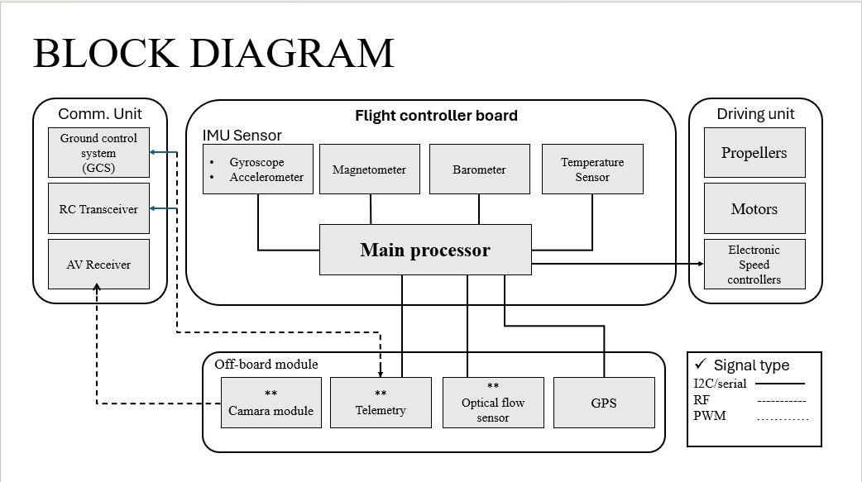

4.COMPONENTS EXPLANATION
Flight Controller
The flight controller acts as the brain of the drone. It processes data from various sensors such as the IMU and GPS and controls the motors to maintain stability, direction, and altitude during flight. It ensures smooth autonomous navigation and overall system coordination.
Brushless Motors
Brushless DC motors generate the thrust required for lift and movement. They are efficient, durable, and capable of providing high-speed rotation needed for stable flight.
Electronic Speed Controllers (ESC)
ESCs regulate the speed of the brushless motors based on signals received from the flight controller. They control acceleration, deceleration, and directional movement of the drone.
Propellers
Propellers convert motor rotation into lift force. Two rotate clockwise and two counterclockwise to balance torque and maintain stable flight.
GPS Module
The GPS module provides real-time location data and enables waypoint-based autonomous navigation. It helps the drone reach the exact destination coordinates accurately.
IMU Sensor (Gyroscope and Accelerometer)
The Inertial Measurement Unit measures orientation, tilt, and acceleration. The gyroscope maintains rotational stability, while the accelerometer detects movement and tilt changes.
Magnetometer
The magnetometer works like a digital compass. It determines the drone’s heading direction and improves navigation accuracy.
Barometer
The barometer measures air pressure to estimate altitude. It helps maintain stable height during flight.
Telemetry Module
The telemetry module enables wireless communication between the drone and the Ground Control Station. It transmits real-time data such as position, speed, and battery status.
RF Transceiver
The RF transmitter and receiver allow manual override control and provide communication backup when required.
Optical Flow Sensor
This sensor measures movement relative to the ground and improves stability, especially in environments where GPS signals are weak.
Camera Module
The camera is used for live monitoring, surveillance, and identifying safe landing zones during delivery.
Temperature Sensor
The temperature sensor monitors environmental or payload conditions to ensure safe transport of temperature-sensitive medical supplies.

5.IMPLEMENTATION METHODOLOGY
The implementation and methodology of the Autonomous Drone System for Emergency Medical Transportation involve designing, assembling, and integrating both hardware and software components to achieve safe and efficient medical delivery. Initially, the drone frame is assembled with brushless motors, propellers, and Electronic Speed Controllers (ESCs), and the flight controller is integrated with essential sensors such as GPS, IMU, magnetometer, and barometer. A telemetry module is connected to enable real-time communication with the Ground Control Station. After hardware setup, the system is calibrated and programmed with GPS-based waypoints corresponding to the emergency destination. During operation, the drone performs autonomous takeoff, follows an optimized flight path, and maintains stability using continuous sensor feedback. Obstacle detection mechanisms monitor the surroundings to prevent collisions, while telemetry data provides real-time updates on position and battery status. Once the medical payload is delivered safely, the drone activates Return-to-Home mode to ensure secure landing, thereby completing the mission efficiently and reliably.

CIRCUIT DIAGRAM
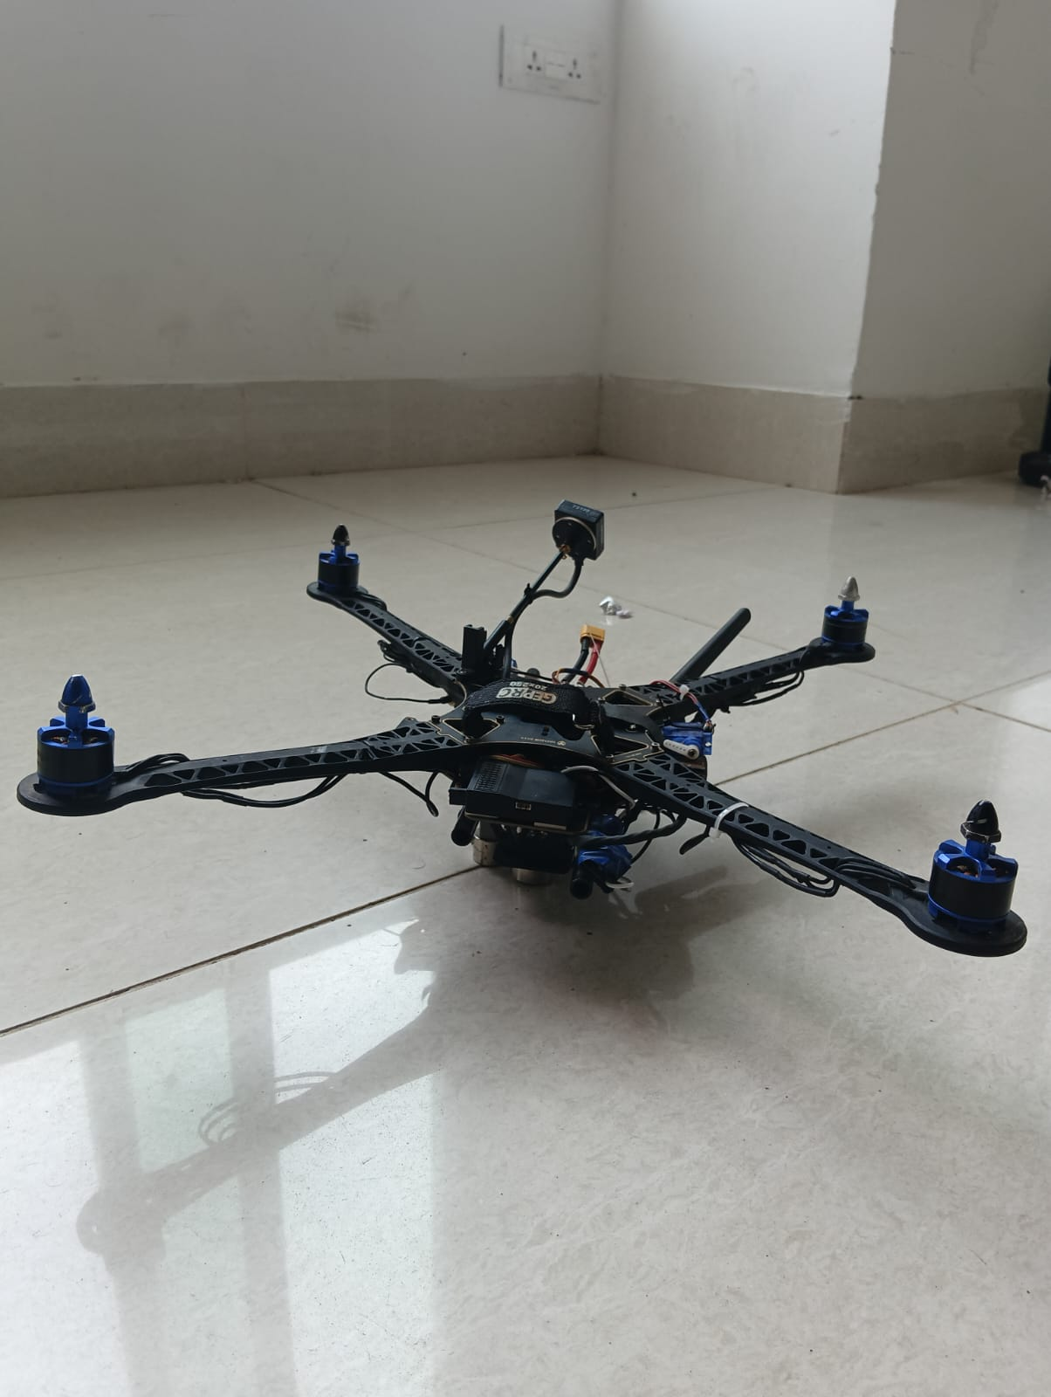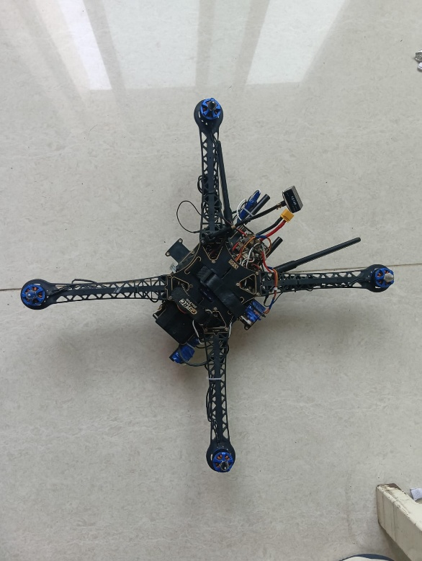
8.CONCLUSION
The Autonomous Drone System for Emergency Medical Transportation demonstrates the potential of UAV technology in improving emergency healthcare logistics. By integrating GPS-based navigation, real-time telemetry, obstacle detection, and safety mechanisms such as Return-to-Home mode, the system ensures fast, reliable, and secure delivery of critical medical supplies. This approach significantly reduces response time compared to traditional ground transportation, especially in remote, disaster-affected, or traffic-congested areas.
The project highlights how autonomous drones can enhance healthcare accessibility and support disaster management efforts. Although challenges such as battery limitations and weather dependency exist, continuous technological advancements can further improve system efficiency and reliability. Overall, this project provides a practical and innovative solution for modern emergency medical transportation and contributes toward the development of smart, life-saving delivery systems.
FUTURE SCOPE
The Autonomous Drone System for Emergency Medical Transportation can be further enhanced by improving battery efficiency and flight range to support long-distance deliveries. Future developments may include AI-based route optimization for faster and safer navigation, temperature-controlled payload compartments for transporting sensitive medical supplies, and advanced communication technologies like 5G for real-time monitoring. The integration of swarm drone systems, automated docking stations, and solar-assisted charging can increase operational efficiency and sustainability. With proper regulatory approvals and technological advancements, this system has the potential to be expanded into a large-scale, fully automated medical delivery network that significantly improves emergency healthcare services..

